UDL Stepping Stone: Introduction + Exploration
“We’ve all heard about Universal Design for Learning. We’ve heard that it’s about “removing barriers” to learning and increasing access to information and ideas; it’s about providing We have probably all heard different things about it and have various levels of understanding. There probably is no one best way to describe, explain, or tell about UDL. In fact, it might be best that you take some time to freely explore the principles of UDL on your own.

We are fortunate to have some excellent resources to check out. Our goal for this session is to pick out some of the Big Ideas behind UDL and talk about how they might be useful for our kids in the classroom.

So, let’s get to a computer and get started.”

Materials needed:
- Computers/ Computer lab
- What? So What? organizer (below)
- Poster paper (optional)
- Email links below to your staff before the session.

1) Participants will visit:
http://www.udlcenter.org/ http://www.cast.org/ calvertuniversal.com
Consider emailing these links to your staff prior to the session.

2) Participants will use the What? So What? Organizer to document thinking. (30 minutes)
3) Participants will gather and discuss what was seen.
Options:
- Participants can meet in small groups to share what was seen. After, groups will share two highlights and their possibilities for learning in the classroom.
- Place three posters around the room. Label them:
*Engagement
*Multiple Modes of Representation
*Multiple Modes of Action and Expression.
Participants will place there highlights on the appropriate title. Many will fall under more than one label. And that’s great! After, a gallery walk and debrief can take place.
- A Padlet (Poster paper can be used here, as well.) can be created so that as participants are investigating the site, they can add their highlights and view others on Padlet.
Padlet.com
- Use the Connect-Extend-Challenge protocol (below) to center thinking.
4) The facilitator will distribute the UDL Placemat (below). Remind participants that while there is no perfect lesson for all students, we can increase our chances of creating superior lessons if we ask ourselves the three questions (on Placemat) when we plan.
Option for further investigation:
Groups can form into affinity groups for a few months or the year. Participants can select which UDL principle (engagement, representation, or expression) in which they are interested. Using the same websites, groups can investigate the applications for teaching each meeting. After two or three meetings, the staff can gather to learn from the other groups as they share their findings.

Resources
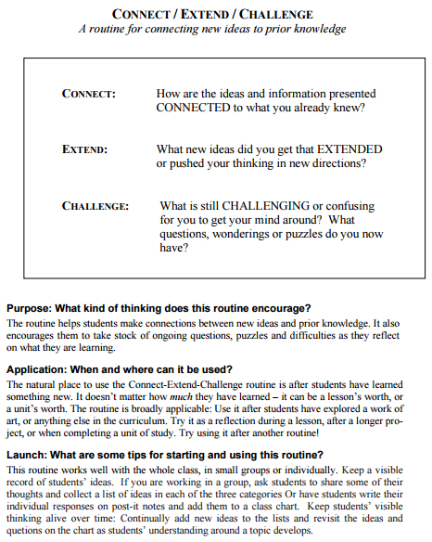

Connect – Extend – Challenge
Connect
How are the ideas and information presented connected to what you already know about good teaching?
Extend
What new ideas did you get that pushed your thinking in new directions?

Challenge
What is still challenging to you? What questions do you now have?

*Try this in the classroom after a reading, video, discussion, or activity!
What? So What?
Information and Ideas | Why is this important for the classroom?

