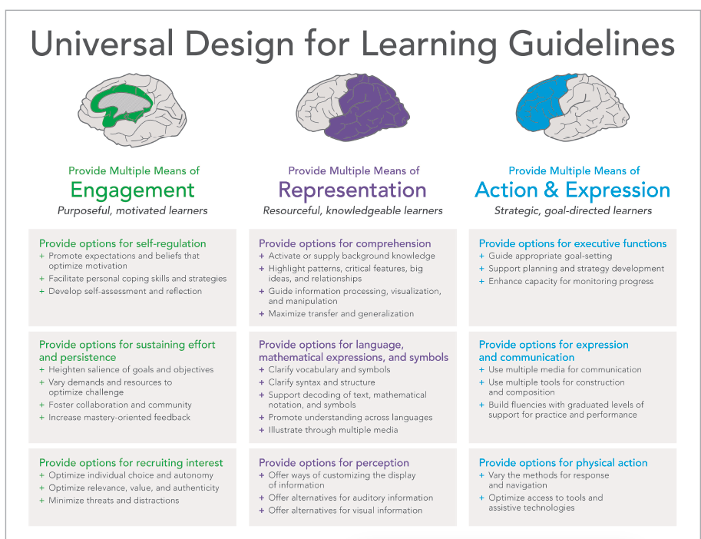
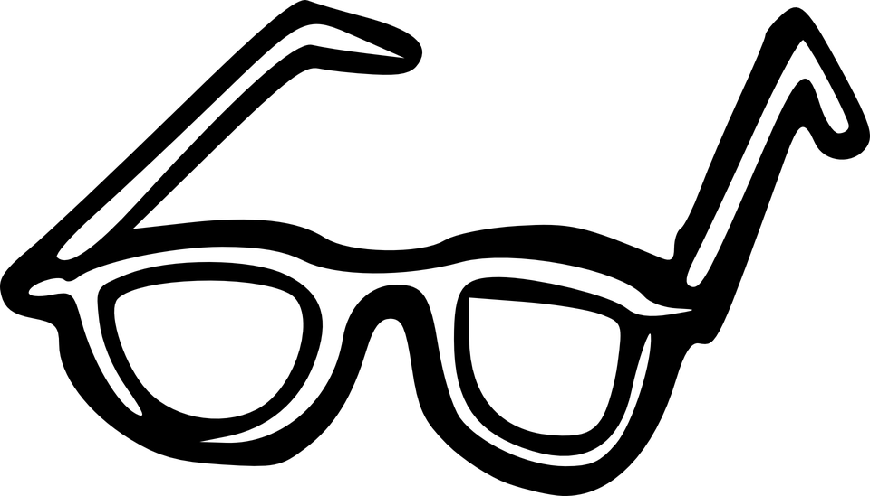
Looking for UDL Protocol
Goal: to use the UDL framework to “look for UDL”

Universal Design for Learning:
- Is a framework for thinking about the design of a lesson or learning event - it is not a checklist or a concrete “thing” that can be used or not used.
- Looks different in every classroom, school and district due to differences such as resources, context, content, and student and educator variability.

Although there are challenges in identifying UDL, there are ways to know that UDL is present in a learning environment. This protocol can be used flexibly to look for UDL in a wide range of settings such as in a classroom, classroom video, faculty meeting, campus tour, lesson planning session, and more! Use this protocol accompanied with the UDL guidelines to help you “look for” UDL in action.
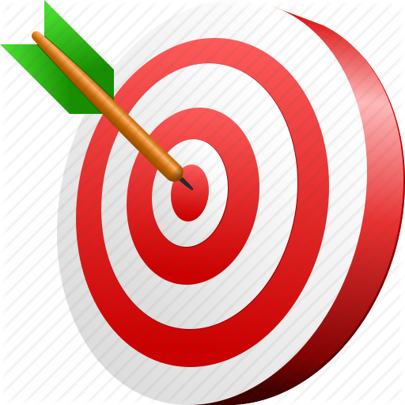
- The goal of the lesson/learning event should be clear to all.
  - How do you know that the goal is clear? What do you see and/or hear to indicate that all learners understand the goal? Are students are aware of the goal and able to restate it?
The clear goal is:

- What UDL options are available for all learners in the learning environment?
  - Record UDL Options available that support the intended learning goal.
Options for Engagement:

Options for Representation:

Options for Action and Expression:

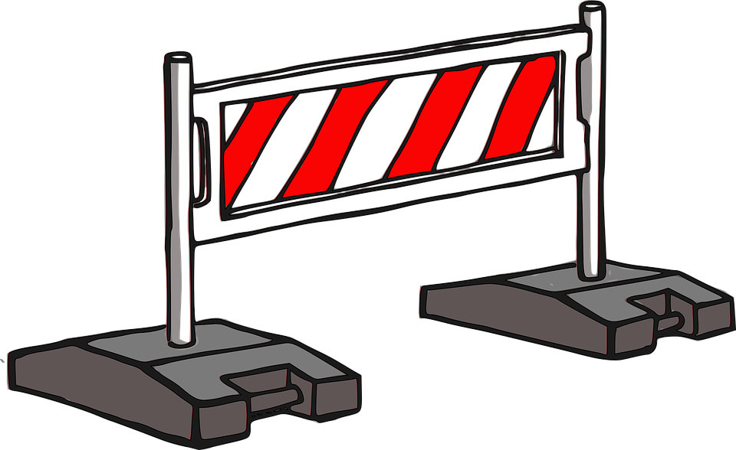
- What noticeable learning barriers prevent learners from achieving the goals?
How can the UDL guidelines be used to overcome these barriers?

BARRIERS | UDL Option to overcome barrier

- In listening to what is going on, what do you hear that suggests that this environment is promoting expert learning, i.e. learners who are purposeful and motivated; resourceful and knowledgeable; strategic and goal directed?
Expert Learning Evidence:

- What do you hear and see that indicates that this learning environment is supportive of all learners and recognizes variability of learners as being the norm?
Variability:

