UDL Stepping Stone: Visible Thinking Routines
Notes:
1) This Stepping Stone is designed to point teachers toward the use of Tools for Mental Engagement located in the Tools for Mental Engagement tab of calvertuniversal.com. It connects with engaging students and issues of Equity and Diversity.

2) An extension session is described on page 7. This piece explores the use of the See, Think, Wonder thinking routine. http://www.visiblethinkingpz.org/VisibleThinking_html_files/03_ThinkingRoutines/03c_Core_routines/SeeThinkWonder/SeeThinkWonder_Routine.html

3) Questions: contact udl@calvertnet.k12.md.us

From Making Thinking Visible: Routines exist in all classrooms; they are the patterns by which we operate and go about the job of learning and working together in a classroom environment. A routine can be thought of as any procedure, process, or pattern of action that is used repeatedly to manage and facilitate the accomplishment of specific goals or tasks. Classrooms have routines that serve to manage student behavior and interactions, to organizing the work of learning, and to establish rules for communication and discourse. Classrooms also have routines that structure the way students go about the process of learning. These learning routines can be simple structures, such as reading from a text and answering the questions at the end of the chapter, or they may be designed to promote students' thinking, such as asking students what they know, what they want to know, and what they have learned as part of a unit of study.

Today, we are going to consider the importance of exposing our students to good thinking routines and habits.

Materials needed:
- Poster paper and sets of two different colored markers.
- Video: Documenting Students’ Thinking (2:13) https://www.youtube.com/watch?v=ZqYIFoizPlM
- Copies of “I used to… But now I…”
- Option: “5 Thinking Routines” http://langwitches.org/blog/2015/01/11/from-visible-thinking-routines-to-5-modern-learning-routines/comment-page-1/

Directions:

1. Inform participants of the session focus. Option: Read or paraphrase the description above.

2. Place several sets of three posters on the walls. For each set of three, label one THINKING, one VISIBLE, and the third ROUTINES. Place a certain color marker under each poster.
Option: Use only the THINKING and ROUTINE poster if there is limited time.

VISIBLE |  | THINKING |  | ROUTINE

3a. Divide participants into groups of 3,4, or 5. Each group will go to a poster and write words, ideas, connections, and questions that relate to the given word. (3-4 minutes.)
3b. Groups will keep their markers and switch to another poster. In addition to writing their own thoughts about the given word, they may also comment on the writing from the previous group. (3-4 minutes.)
3c. Repeat for the remaining poster. (3-4 minutes)

Option: Groups may return to their original poster to see other groups’ ideas.

4. Say to participants, “Before we discuss what we wrote, let’s think about what we just did. Let’s take 60 seconds in silence to think about our process. What happened? What did it feel like? What were the benefits of considering these words like this? Why do you think we did it this way?” Take the full 60 seconds.

5. Facilitator will solicit comments. Comments will possibly include:
- I got to think about what I was going to write.
- I listen to others.
- I built some idea from what I saw.
- There was no pressure.
- It wasn’t really like an assignment.
- It was sort of anonymous. We all had the same color pens.
- There were no wrong answers. (To address this, you can ask participants to consider what would happen if each group decided on the two most important ideas written on a poster, circled them, and then had to support their thinking. This usually eliminates incorrect thinking.)

6. Now, focus on the writing on the THINKING poster. Facilitator can ask someone to read.
Highlight that the words written on the poster are “exactly what we want in our classrooms every day. But sometimes thinking is hard to see and know what’s really going on inside kids’ heads. This brings us to the word Routine…”

7. Read the comments on the ROUTINE POSTER. Comments may include:
- Helps with discipline
- Helps kids to know what to do
- Safe
- Saves time
- Can be boring (It can be if there is limited thinking involved.)
- Process
- It’s a sequence.
- Patterns
For this conversation, say that “we have routines for everything, don’t we? Kids have routines for getting off the bus, walking into your class, passing in papers, answering questions, and even going to the bathroom. But, what about thinking? It seems that there are good ways of slowing and sequencing thinking so that we arrive at proper conclusions to be worked with further.
Examples:
*When we listen to a politician, we first slow down, compile information, then make
judgements.
*Before eating something, we look at the ingredients then consider their possible impact.
*When we see a physical or scientific phenomenon (something cool) we ask ourselves,
“What is going on here?” before trying to make conclusions about what we saw and why.
*When we read something challenging, we take note of the information then decide on
the meaning.

The same is true for our students in class. We need to provide them regular chances to think for a moment, listen to each other, and develop a common base-line understanding of a topic, text, issue, or problem before being asked to complete a formal task.

8a. Examine the VISIBLE poster and share what is written.

8b. Ask groups why it is important to make student thinking visible.

9. Say: The Tools for Mental Engagement offer quick and effective ways to bring out good thinking from students. They can be used in any class and in any content.

10. Participants will watch video: “Documenting Student Thinking” https://www.youtube.com/watch?v=ZqYIFoizPlM

11. In groups, discuss the some of the questions:
- Why is visible thinking important?
- How does the use of visible thinking help disengaged students?
- How can we use a thinking routine (like the one we used today) be used in class this week?

Option: Have teachers visit the Visible Thinking Routines or show them on calvertuniversal.com
(Suggestion to start: SEE, THINK, WONDER and START, STOP, KEEP)

Option: Distribute the UDL Placemat and ask groups to connect UDL principles and central ideas explored in the session.

12. CLOSING: Use the “I Used to Do/Think…” routine to capture final thoughts. (Below)

Follow-up: Ask participants to experiment with the SEE, THINK, WONDER routine and meet to share the results: What worked? What didn’t? How can it be used again with greater effect?

I USED TO THINK…, BUT NOW I THINK…
A routine for reflecting on how and why our thinking has changed

Purpose: What kind of thinking does this routine encourage? This routine helps participants to reflect on their thinking about a topic or issue and explore how and why that thinking has changed. It can be useful in consolidating new learning as participants identify their new understandings, opinions, and beliefs. By examining and explaining how and why their thinking has changed, participants are developing their reasoning abilities and recognizing cause and effect relationships.

Application: When and where can it be used? This routine can be used whenever participants’ initial thoughts, opinions, or beliefs are likely to have changed as a result of instruction or experience. For instance, after reading new information, watching a film, listening to a speaker, experiencing something new, having a class discussion, at the end of a unit of study, and so on.

Launch: What are some tips for starting and using this routine? Explain to participants that the purpose of this activity is to help them reflect on their thinking about the topic and to identify how their ideas have changed over time.
For instance: When we began this study of ________, you all had some initial ideas about it and what it was all about. In just a few sentences, I want to write what it is that you used to think about _________.

Take a minute to think back and then write down your response to “ I used to think…”
Now, I want you to think about how your ideas about __________ have changed as a result of what we’ve been studying/doing/discussing. Again in just a few sentences write down what you now think about ___________.
Start your sentences with, “But now, I think…”
Have participants share and explain their shifts in thinking. Initially it is good to do this as a whole group so that you can probe participants’ thinking and push them to explain.
Once participants become accustomed to explaining their thinking, students can share with one another in small groups or pairs.

Think about connected ideas and instruction and complete the following.

I used to (think, do)… ________________________________________________________________________________________________________________________________________________________

Now I …
________________________________________________________________________________________________________________________________________________________

From visiblethinkingpz.org
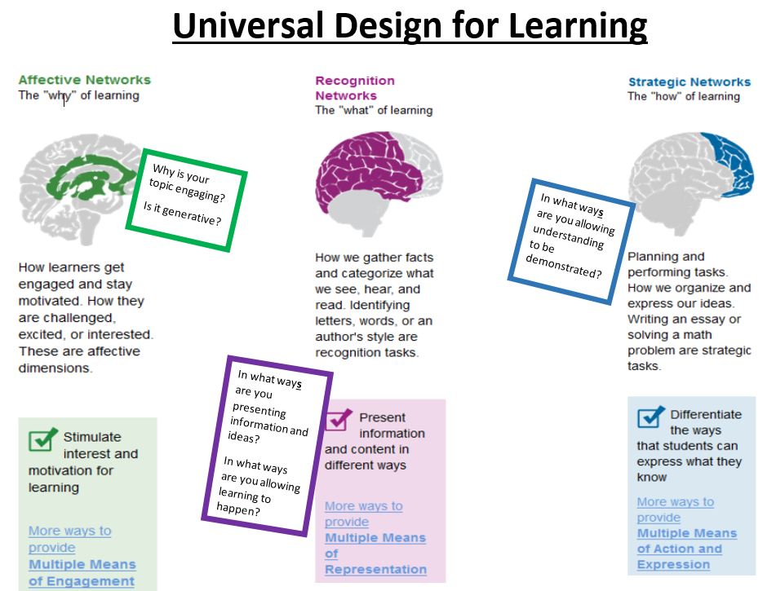
Extension session: Exploring Ideas with See, Think, Wonder
Directions:
1) Choose an image to share with participants. The image can be shown on a screen, printed, or both.
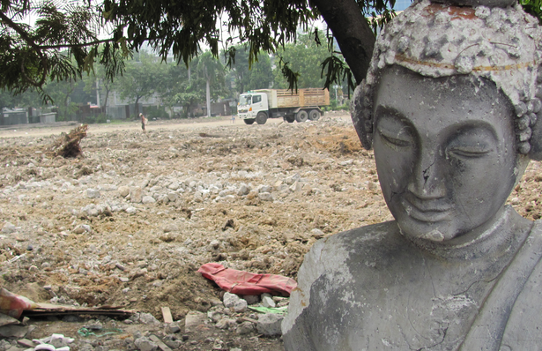
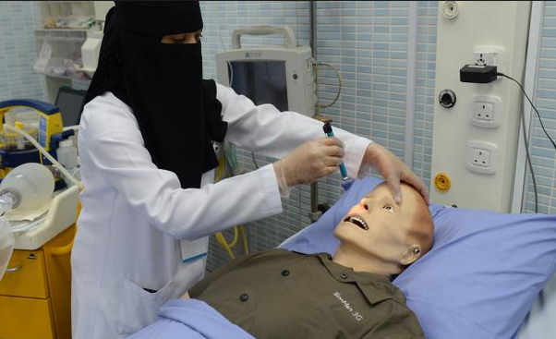

2) Participants will examine the photo independently. (1-2 minutes)
Participants will use the See, Think, Wonder template. (Two templates below)
3) Participants discuss strictly what they see. No inferencing or conclusions. If participants tend to jump to conclusions, ask them, “What do you see that makes you say that?” and/or “Is there something present in the photograph that tells us this?” Try to stick to things that are seen directly in the photo. This is important as we want to model a correct thinking routine that will benefit all students in the classroom.
4) After you have established a list of “what’s there” take 1-2 minutes to independently write out what each participant “thinks” about it; this includes any inferences, conclusions, statements, insights, connections, etc. (1-2 minutes)
5) Participants may discuss the THINK portion.
Option: Participants may repeat the process using the Wonder portion. Here, participants pose questions and discuss curiosities they have. This portion is intended to engage and generate further interest.
6) Say to participants, “Before we discuss what we wrote, let’s think about what we just did. Let’s take 60 seconds in silence to think about our process. What happened? What did it feel like? What were the benefits of considering these words like this? Why do you think we did it this way?” Take the full 60 seconds or longer.

7) Discuss.

Option: Use the Microlab strategy. (See the Peer Communication Stepping Stone on calvertuniversal.com http://www.calvertuniversal.com/#!project08/c1n22

8) Ask participants to identify ways this can be used in the classroom.
Suggestions:
- Used with a single title, word, phrase, quote, or paragraph in all types of texts.
- Introducing a concept in science
- Engaging students in an event in history
- Showing students a visual or text-based problem in math.
- with a piece of music

Follow-up: Ask participants to experiment with the SEE, THINK, WONDER routine and meet to share the results: What worked? What didn’t? How can it be used again with greater effect?

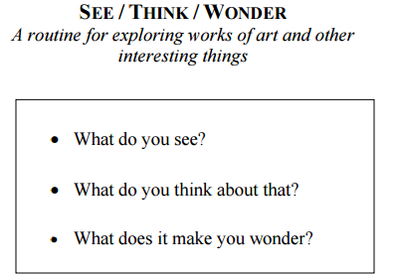
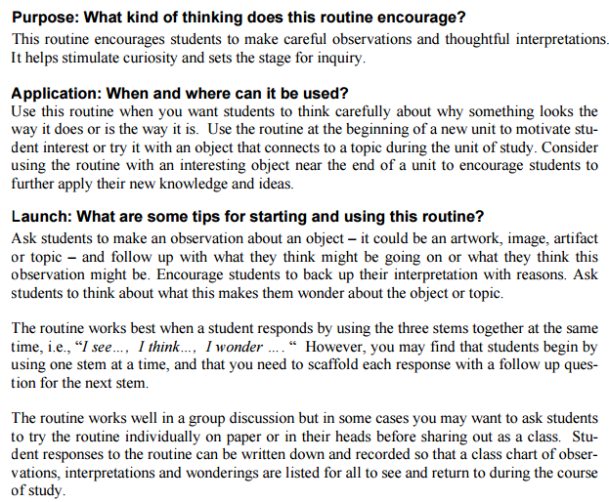

What do I
SEE?
What do I THINK about this?
What do I WONDER? What questions do I have? What doesn’t make sense?
I see a photograph that shows ______________________________________________________________________________________________________________________________________________________________________________________________________________________________________________________________________________________________________________________________________________________________________________________________________________________________________________________________________________________________________________________________

I think…
_______________________________________________________________________________________________________________________________________________________________________________________________________________________________________________________________
I also think…
_______________________________________________________________________________________________________________________________________________________________________________________________________________________________________________________________
I wonder…
_______________________________________________________________________________________________________________________________________________________________________________________________________________________________________________________________

I also wonder … _______________________________________________________________________________________________________________________________________________________________________________________________________________________________________________________________

